Marine Cloud Brightening (MCB) Interface specification

Prepared by: Kevin Lister
Date: 26th April 2015

Version control
Revision | Author | Approver | Change history
1 | Kevin Lister | Severn Clarke | Initial presentation

Table of Contents
1 Introduction 3
2 System Overview 3
2.1 Ship based installation overview 4
2.2 Fixed installation 4
2.3 Low footprint version 5
2.4 Key differences 5
3 Interface specification – ship based installation 7
3.1 Diffuser plates to Aerostat 7
3.2 Diffuser plates to Fluidic Oscillator 7
3.3 Brine reservoir to Diffuser plates 8
3.4 Initial Testing and validation 9
3.5 Aerostat 9
3.6 Umbilical cable connection 9
3.7 Dynamic Damper 11
3.8 Umbilical reel 11
3.9 Hydraulic Power System 11
3.10 Gas power supply 11
4 Fixed installation interfaces 12
4.1 Aerostat 12
4.2 Hydrogen supply 12
4.3 Floating platform 12
4.4 Power supply 12

Introduction
This document covers the interfaces between the components that together constitute the MCB system.
The purpose of this document is to identify and specify the critical interfaces and where possible give an idea of their performance characteristics such that risks in an accelerated development programme can be identified and managed accordingly.

System Overview
The key component of the MCB system is a fluidic oscillator (FO) which creates high frequency pressure pulses that are directed towards a diffuser plate with micron sized pores. The gas pulses will pass through the diffuser plate and through a thin film of brine water in which micro bubbles will be created. As the bubbles rise from the surface, they will be burst and create nano sized droplets.
This system has the advantage of being energy efficient, has no moving parts and is not susceptible to contamination in the brine.
The fluidic oscillator will be located in an aerostat and fluid will be pumped to this using an umbilical cable.
The MCB system will consist of three general layouts all of which share common components, these are:
- Mobile ship based with aerostat for semi-permanent installations on ships that will be specifically chartered for the purpose.
- Fixed installation for deployment at prime MCB sites which can be operated either by externally delivered power or integrated wind turbines.
- Low footprint version for installation on commercial shipping and/or aircraft.
Descriptions of which follow.

Ship based installation overview

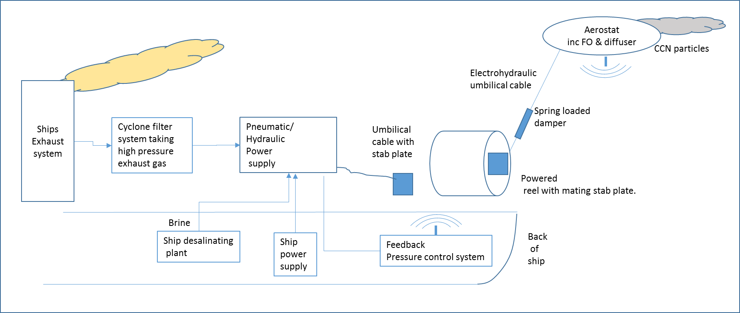
Figure 1 Ship based installation
It is intended that this system can be quickly configured to any suitable ship. It will use the ship’s interfaces to most optimal effect. The main interfaces will be:
- The ships exhaust to provide warm air with SO2 to assist in nucleation
- The brine from the ships desalination plant
- The pneumatic or electrical power supplies.
- Physical space, probably near the back of the ship for installation of the reel and deployment of the aerostat.

Fixed installation
The diagram below shows a potential configuration for a fixed installation. It is possible that the fixed installation includes a wind turbine for power production, alternatively the power can be supplied remotely either from a local wind turbine farm, a local shore based supply, or local oil platforms.

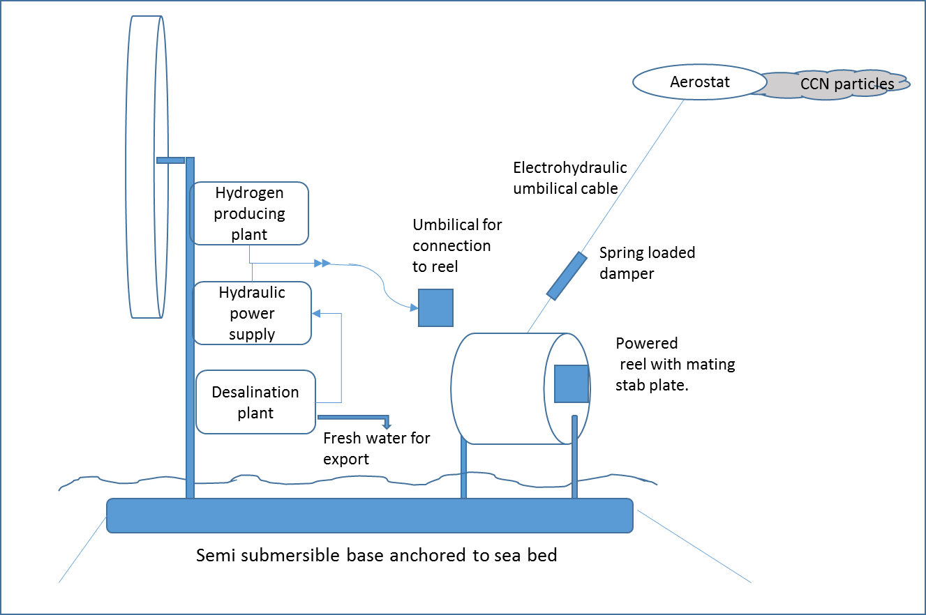
Figure 2: Fixed installation
It is unlikely that a fixed installation would be utilised throughout the year. An installation in the northern subtropics would be used most intently from June to September. A southern subtropics installation would be used most intently from December to March. During the cooler periods the installation, if it has its own power supply, can be used commercially to export fresh water from its desalination plant or electrical power to locally available markets.

Low footprint version

The low energy requirement of the fluidic oscillator and the small physical dimensions allow development of a version that can be deployed on normal commercial vessels at low capital and operating cost.
This would not have the aerostat and overcome the loss of efficiency with a significantly increased volume of spumes. It would easily be located on a top-stern facing deck of a ship.
If sufficient of these are attached to commercial vessels then global coverage can be obtained and operations can be controlled remotely from a central point.
The low footprint version can also be quickly modified for airborne operation using existing high payload cargo planes suitable for operations at relatively low level such as a C-130 Hercules or equivalent.

Key differences

It is assumed that the ship based aerostat will be lowered in the event of extreme weather. Thus there will be a premium on handling in its design. By contrast, the fixed installation must be able to withstand the most extreme weather conditions, thus there will be a design premium on weather tolerance at the expense of handling.
It is expected that hydrogen will be used as the lifting gas on fixed installation due to its lower cost and lighter weight compared to helium. However, hydrogen diffusion through the aerostat material is likely to be a bigger issue than with helium. This will necessitate a hydrogen production plant on the fixed installation version.
While hydrogen would be the preferred gas from a lifting and cost perspective on the ship based installations, this would depend on satisfactory safety cases being prepared. If these are not possible then a helium supply would be needed.
The low footprint version would require a manual override, such that the captain of the ship can stop operations in the event of emergency.

Interface specification – ship based installation
This interface specification works backward from the diffuser plates to the power supplies

Diffuser plates to Aerostat
It is anticipated that the diffuser plates will be located on the upper surface(s) of the aerostat such that the low pressure moving air stream will liberation the droplets from the plates.
The design options and interfaces are:
- The diffuser plates can be either sintered material or laser drilled. A laser drilled surface will offer lower gas resistance and most likely higher consistency of produced droplets.
- The diffuser plates may need to be positioned perpendicular to the air stream.
- The mass of salt in the droplets is critical to the nucleation performance. This can be fine-tuned by the salinity of the brine delivered to the diffuser plates along with the gas flow and subsequent resonant frequency from the fluidic oscillator.
- It is likely that we will need to maximise the surface area of the diffusers to increase the volume of nucleation.
- At this stage it is not possible to calculate the size of salt particles produced or number for litre of fluid delivered. However, initial estimates suggest that with the fluidic oscillator operating at 500Hz with the output diffusing through a laser drilled plate with 4 micron diameters spaced 3 diameters apart as shown below, then a droplet production rate of 3.5X10⁹ per cm² per second can be achieved. Configuration as shown:
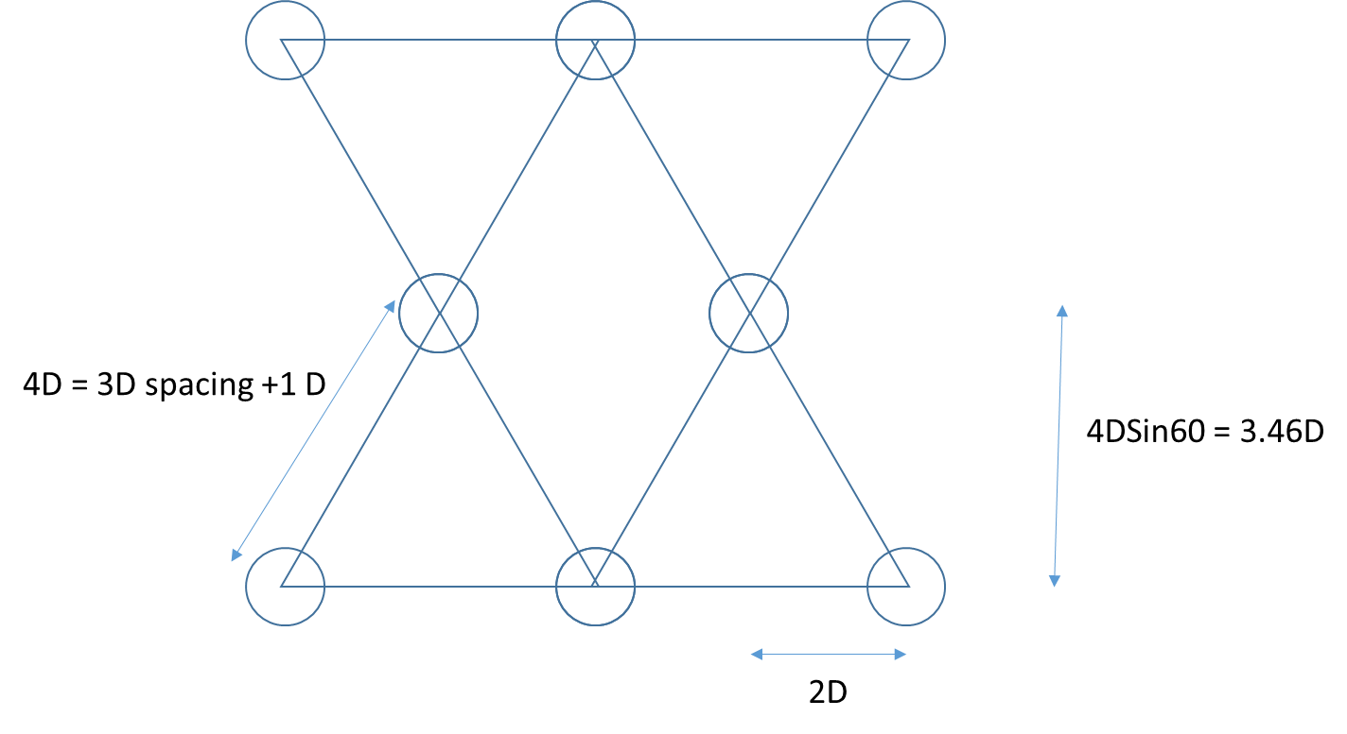
- Current computer modelling suggests that the salt mass per droplet should be in the order of the 1e-19kg. Experimental validation will be needed to determine the weight range of the salt in the spray

Diffuser plates to Fluidic Oscillator
Each fluidic oscillator will connect to two diffuser plates. It will need to be determined if the diffuser plates should be positioned perpendicular to the gas flow.
The design of the diffuser plates needs to be optimised for area and configuration.
It is envisaged that the fluidic oscillator will be operated at the highest possible frequency. This will ensure that the smallest droplets are created maximise the production of droplets per square centimetre.
The diffuser plate/Fluidic oscillator assembly must be capable of fitting within the depth of the boomerang wing configuration of the aerostat.
It is envisaged that a number of fluidic oscillators will be installed in the aerostat, each feeding their own diffuser plates. As these will be all be fed from the same pressure supply, then pressure controllers on each fluidic oscillator may be needed to ensure that the gas feed does not get diverted preferentially to one diffuser or to stop oscillations occurring.
The diffuser plate can be either sintered steel or laser drilled. Laser drilling, though more expensive, is expected to give significantly better performance and long scale production runs are likely to lead to cost reductions. Laser drilling allows for a plate thickness of approximately 0.5mm to be used which will reduce pressure loss and allow a higher fluidic oscillator frequency to be maintained.
The material selection has yet to be determined. Initial testing suggests that the metallic surfaces are better for a bubble formation. The material selected must be able to resist corrosion from high salt concentrations, which leads to the use of Inconel or equivalent.
The risk of salt build up on the surface may be a risk given the high concentrations that are being used. If this is found to be an issue, then back flushing will be incorporated into the operating regime.

Brine reservoir to Diffuser plates
A conceptual layout is shown below
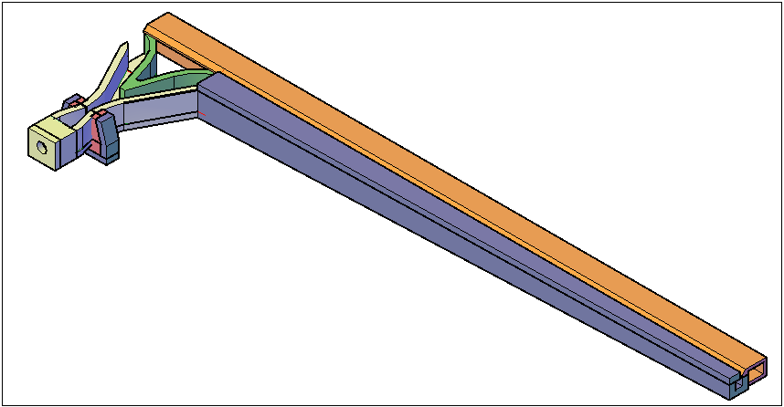
Figure 3: Illustrative layout of fluidic oscillator, diffuser and brine reservoir
Fluid is fed from the brine reservoir to the diffuser plates. This brine pressure will have to be kept slightly above ambient pressure and carefully controlled to avoid either starvation or flooding of the diffuser plates.
A precise pressure control system will thus be needed. It is likely that fine control will be provided in the aerostat and course pressure control will be needed on the ship based hydraulic power pack with the two operating in tandem. The fine and course control systems could be linked wirelessly or through a signal cable running through the umbilical.
Testing will be needed to verify that the brine will not flood through diffuser plates in the event of gas starvation and design solutions may need to be incorporated if this is identified as being a risk.

Initial Testing and validation
Testing requirements will cover:
- Lab based testing: Quantification of CCN particulate output in terms of numbers or particles and mass of salt per particle for different operational configurations. The main input variables to be established will be gas pressure, depth of brine film on the diffuser plates, fluid flow rate and salinity.
- Environmental testing: spray release from a light aeroplane or airship. This will be done at different altitudes, different latitudes, different weather conditions and atmospheric conditions to establish response data.

Aerostat
Aerostat configurations are still being developed. It is envisaged that the aerostat will derive lift through a combination of being lighter than air and through aerodynamic lift. It is envisaged that it will be in the general shape of a boomerang shaped wing surface to optimise lift to drag ratio.
To ease deck handling the aerostat may be of a bi-plane configuration.
The diffuser plates will be located on the upper surface such that the airflow over them will assist with the dispersal of the droplets.
The aerostat will be pressurised by either hydrogen or helium, subject to safety cases.
The aerostat must provide enough buoyancy to lift the diffusers and the umbilical to a height of at least 1000m.
Once at this height, airflow over the aerostat will provide lift that will enable the brine to be pumped up.
The aerostat must have a sufficiently strong mooring point which will support the weight of the umbilical along with additional lift and drag forces.
Aerostats need to be deployable and recoverable from a ship.
The aerostat size will ultimately be determined by the hydraulic power that is available to deliver the brine to the aerostat and the maximum aerodynamic loading that can be safely applied to the ship.

Umbilical cable connection
The umbilical will fulfil three tasks: it will provide the pressurised exhaust gas and brine to the Aerostat; it will carry the hydrogen or helium gas to the aerostat for topping up the buoyancy along the same line as used for the exhaust gas and this will be controlled by a diverter valve, it will carry electrical power and signals; it will provide the tensile strength to anchor the aerostat to the ship.
To minimise air resistance and weight, we expect to use a tube within a tube arrangement, as shown. The loads will be transferred along either the inner hydraulic tube or the outer pneumatic tube.
With this tube-within-a-tube configuration, an appropriate load bearing gland will need to be designed at either end.
The external wall of the tube will need to be covered in a conducting material for lightening protection.
The electrical signal cables can be run up the gap between the two hoses.

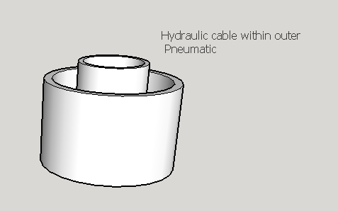
Figure 4 Tube within a tube concept for umbilical

As the diameter of the hydraulic line increases, then the power consumption needed to pump the brine to the aerostat reduces with the square of the diameter. At the same time, the weight of the water to be carried in the umbilical increases forcing the aerostat to increase. Thus the design trade-offs with the umbilical are critical to the overall system performance.
The following table shows these compromises for standard hydraulic hoses operating with a flow rate of 1 litre/second at different heights:

Height = 1,000m | ½” hose | ⅜” hose | ¼” hose
Power requirement (kW) for pumping brine at 1 litre/sec | 10 | 11 | 21
Mass of water (kg) | 268 | 151 | 67

Height = 1,500m | ½” hose | ⅜” hose | ¼” hose
Power requirement (kW) for pumping brine at 1 litre/sec | 15 | 16 | 31
Mass of water (kg) | 179 | 100 | 44

The power output even with the ¼ inch hose is trivial compared to the available power on a ship. Furthermore, the power loss will result in warming of the brine which will potentially improve the performance of the droplets.

Dynamic Damper
A dynamic damper may be necessary on the umbilical cable to dampen shock loads caused either by atmospheric turbulence or pitching and rolling of the ship.

Umbilical reel
A powered reel will be used to store the umbilical.
This needs to be of sufficient strength to resist the drag and lift generated from the aerostat.
The umbilical reel will be connected to the hydraulic power supply through a high pressure hydraulic swivel or stab plate. If the latter option is used, then the aerostat would be deployed to the required height when the reel would be locked in position and the stab plate connected.
It is anticipated that a standard off-the shelf powered reel assembly will be able to be used.

Hydraulic Power System
The hydraulic power system may operate from a ships electrical power system or compressed air supply.
It will need to be specified to run on highly concentrated brine.
The feedstock will be either filtered sea water or the output from the ship desalination plant. If sea water is used, additional salt can be added to this. It is likely that some control will be needed of the level of salination.
Hydraulic accumulators on the output line will dampen pressure pulses from ,the pump.

Gas power supply
It is intended that a bleed be taken of the ship exhaust which is then filtered to remove soot particles. This will have the advantage of being hot and the sulphur particles will also contribute to the MCB effect.
Depending on the engine, it may be possible to take this directly from the pistons which will thus negate the need for any subsequent pressurisation.
The filtration system will be based on cyclonic filtration.
The use of sulphur laden exhaust gases may impose further corrosion related issues with the diffuser plate and other components in the system.

Fixed installation interfaces

The list below describes the differences from the ship based installation

Aerostat
The aerostat will need to be designed to withstand all weather conditions. It will therefore need to be as strong as possible with the minimum drag. Handling will not be such an issue as on a ship.
It is anticipated that it will be launched from a dedicated ship or maintenance platform.

Hydrogen supply
No safety related issues are expected with the use of hydrogen for the lifting gas. To ensure hydrogen diffusion through the skin of the aerostat is accommodated, a hydrogen production unit will be incorporated.
Any excess hydrogen can be used to power the hydraulic unit.

Floating platform
It is envisaged that a semi-submersible floating platform is provided to give the required stability in rough seas.
The fixed installations could also be installed on oil and gas platforms that may be approaching the end of their operational lives.

Power supply
The system can be designed around its own wind turbine. During winter periods this can be used to export power.
Alternatively, the units can be powered externally either from the shore or other available installation such as oil and gas platforms.

