ORGANIC MARICULTURE AND BIOSEQUESTRATION CONCEPT
Condensed version

William S. Clarke

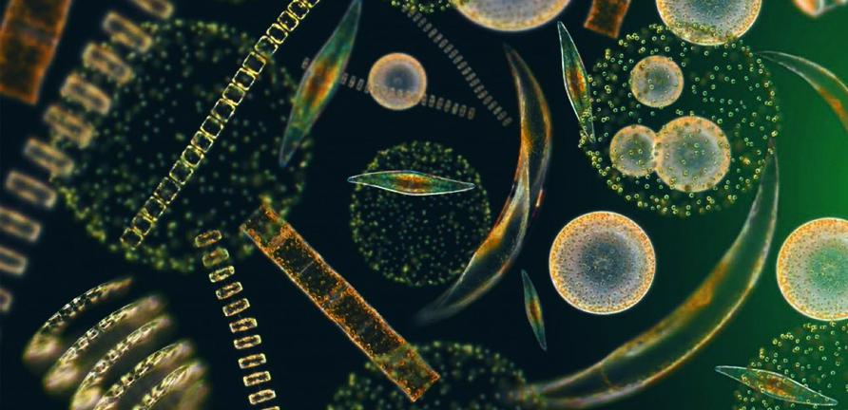
The most important organisms on the planet – Phytoplankton
photo from http://seahack.org/project/secchi-plankton-study/

SUMMARY:

Phytoplankton are responsible for 50 -70% of the oxygen in our atmosphere and are the greatest natural CO₂ capture system we have available to us. Unfortunately, our pillaging of the seas has greatly reduced the level of nutrient supplies that were in the oceans as little as 300 years ago, with the result that phytoplankton and fish numbers are a fraction of what they once were. We learned long ago on land that it was necessary to replace nutrients if we wished to maintain fertility of our fields. So too with the seas

It is well known that ocean fertilization can cause great blooms of phytoplankton, but to date the effects of direct fertilization have been transitory due to the delivered nutrients sinking too quickly through the water column.

The flake fertilization method described below has the potential to enable restoration of oceanic and atmospheric carbon levels to pre-industrial ones. It also could provide time for a managed transition to a low-carbon economy and stimulate global economic development. In short, when properly researched, developed and implemented it may represent humanity’s bridge to the future.
The need for such a technology is urgent, as rapidly increasing atmospheric carbon dioxide levels, ocean acidification and recent scientific commentary suggest that we may be close to, at, or even past a global tipping point. By any standard, a failure to remedy this situation poses an unacceptable global risk.
If this method to remediate our oceans and atmosphere by using buoyant flakes carrying tailored fertilizer mixes can be shown to be reasonably safe, timely and cost-effective, it could potentially change the entire dynamic of international negotiations regarding climate change and ocean acidification.
Once validated, the method promises us the capability of sequestering sufficient carbon to reduce atmospheric CO₂ to acceptable levels at an estimated average cost of $11 per tonne of carbon sequestered. Moreover, revenue streams might be engineered to make this actually a profitable enterprise for industry and government. The implications to the global carbon budget are that we may now have a way of repaying our deficit and be able to make a smoother transition to a sustainable energy economy without risk of economic collapse. Beyond being a potential global game-changer, ocean flake fertilization could present one of the most significant industrial opportunities of all time, as was agriculture on land.

DESCRIPTION:

The concept is to deploy buoyant, ultra-slow-release fertilizer flakes designed to cause marine organisms to sequester the excess carbon dioxide for us. The flakes are produced from low-cost, natural and waste materials. The flakes are to be distributed over nutrient-deficient ocean areas to cause ecologically-balanced communities of phytoplankton (diatoms and microalgae), and marine organisms above them in the food chain, to increase many-fold. Such an increase in marine biomass transforms acidifying carbon dioxide into neutral biomass and oxygen. Furthermore, when marine organisms excrete, are consumed in the ocean or die, part of their carbonaceous material sinks to the seabed, where, if conditions are propitious, portions are either biosequestered in deep ocean sediments or are otherwise removed from the terrestrial biosphere for countless years.

The de-acidifying effects of these processes are magnified whenever:
- the ocean depths are cold, and preferably low enough in oxygen, to hinder bacterial degradation of the sunken biomass;
- the rate of descent of the sinking biomass is fast, as is the case with dense aggregates of diatoms and the bodies and excrement of some larger marine species; and
- the components of the fertilizer used are tailored to match the specific nutrient deficiencies known to occur down-current or down-wind from the site of buoyant fertilizer dissemination.
Extra phytoplankton near the surface also substantially increase oceanic reflectiveness (albedo) and marine cloud formation and brightening, leading to oceanic cooling and a reduction in extreme weather events and intensity.

The chosen fertilizer-carrier mix is designed to meet the strict requirements of international agreements on ocean fertilization research and usage, see http://iospress.metapress.com/content/l3nrrdt64f6v0cb0/fulltext.pdf. The buoyant fertilizer carrier comprises rice husks (hulls) with the triple benefit of them being:
- a plentiful, benign, and naturally-occurring waste product;
- light yet durable; and
- high in hydrated silica that diatoms require to make their dense yet porous skeletons (frustules). This helps, as ocean areas remote from land are typically nearly as deficient in silica as they are in iron nutrient.

Minerals are added to the oceans by coastal erosion, runoff, upwelling, dust storms, volcanoes, meteoric dust, and human activities. However, most are lost to the sunlit biosphere because they sink rapidly. Moreover, massive amounts of iron and phosphorus, in the form of fish catch, have been and are being removed from the oceans by humans and seabirds. This remedial concept has been developed to replace those lost minerals, thereby rendering the oceans more productive and enabling their sediments to be a more substantial carbon sink. Eventually, these sediments are transformed into new limestone and fossil fuel deposits.

The flake method provides a substantial business opportunity based on carbon credits and additional fish catch. Given assiduous application of the flake, it is conceivable that the delayed dynamic of transitioning to a sustainable world could accelerate. The chief current roadblocks are the interests and economics fighting the reduction of fossil fuel emissions. Calculations show that if sufficient flakes are disseminated yearly, the total emissions of anthropogenic carbon dioxide might progressively be safely sequestered. The end-state would be reached when the pH of the oceans had been restored to pre-industrial levels and a basis is established for comfortable transitioning to a low-carbon economy.

Additional benefits beyond carbon sequestration would be to: reverse ocean acidification; halt and then reverse global warming; restrain sea level rise; reduce extreme weather events; ensure better-distributed rainfall patterns; and reverse rapidly depleting marine stocks. The latter point may lead to the opportunity of revenue streams from fishing royalties and scientific monitoring.

The most suitable form of iron-silica fertilizer may be the red mud waste product from bauxite refining. Not only does this have other useful mineral components, but it is alkaline, cheap, already finely-divided, and readily-available in tailings stockpiles. Additional suitable, and otherwise uncommercial, sources of iron and other ocean-deficient minerals are ironstone, lateritic soil, various low-grade deposits of iron, and phosphatic clay wastes. The third flake component is lignin, a by-product of the extraction of cellulosic sugars from crop and forestry wastes. Lignin can be used as a plentiful, cheap and durable thermo-adhesive to glue the mineral fertilizer dusts to the carrier husks. Introducing additional gas pockets into the flakes ensures buoyancy for the composite flake. Moreover, when each eventually degrades and sinks, the lignin forms carbonaceous sediment that is fortuitously resistant to conversion into either carbon dioxide or methane.

The fertilizer flakes are simply and economically made by heating the three components differentially, typically using concentrated solar or other heating. The turbulent mix of husk composites, glue, and minerals combine to form durable fertilizer flakes in successive stages. As they fall in a wedge-shaped tower, successive layers of powdered glue and powdered mineral accrete onto all surfaces of each rice husk composite. The flakes are then shipped and pneumatically disseminated widely to the ocean surface. From 0.02 - 2% of any nutrient-deficient ocean surface may be covered in flakes for optimal effect.

Even in rough, ice-strewn polar waters, the slightly buoyant flakes may remain on the surface for a considerable period of time, possibly for a year or more, whilst their nutrients are slowly released, extracted and absorbed by special, concentrating proteins (ligands) in phytoplankton cell walls. Each tonne of iron in the flakes can theoretically produce around 1,000 tonnes of algae or 29,000 tonnes of harvestable, dry weight fish. In practice, carbon sequestration and other losses might reduce these last two figures by ~tenfold.

Under colonisation by phytoplankton and their tiny predators, each sunlit flake will form a miniature green habitat, farm or nursery that anchors or shelters eggs, larvae and organisms, feeds and provides mates for its resident ecology, as well as providing a rich hunting ground for larger species. Undesirable eutrophication (mass die-off and oxygen depletion) is inhibited by the ultra-slow release of the fertilizer and by the predation this allows.

In addition to the benefits discussed above, multi-component fertilizer released from buoyant flakes produces several other desirable results. First, and unlike the highly-soluble commercial fertilizers already tested, it means that little is wasted to the dark depths; virtually all is released in the top several centimetres of best-illuminated, and hence most productive, water. Second, because of the high illumination and partial interruption of sunlight to the depths caused by the presence of sunlight-absorbing flakes and extra plankton in the surface waters, the growing season is extended in polar waters, more CO₂ is converted into biomass, and there are more fish stocks than otherwise. Third, the increased albedo of the plankton-rich green ocean, combined with the consequent reduction in atmospheric CO₂, and the increase in cloud-seeding emissions, mean that both global warming and sea-level rise would first be reduced, then reversed, by essentially natural means, over business-as-usual effects.

After about fifteen years of full operation, the reductive effects of these on global temperatures is estimated to be able substantially to offset global warming. Concomitant biosequestration of carbon would progressively reverse ocean acidification in surface waters, then in the atmosphere and intermediate waters.

Fertilizer flakes and nutriated plumes of phytoplankton are readily tracked and managed. Once the science has been validated and licences for trials approved under international scientific surveillance, business will do the rest because it will be profitable to do so. No other method of reversing ocean acidification is thought to be as: achievable, rapidly effective, sure, safe, sustainable, beneficial, politically-acceptable, and indeed profitable as is this concept.

PHASING:
Three broad phases are required to implement the concept, with the later ones somewhat overlapping, but being dependent for their full implementation upon the success of earlier and concurrent phase results. The broad phases are these:
- Laboratory research to confirm the flake’s effect upon plankton and marine life in nutrient-deficient seawater, flake durability, the comparative suitability of the flake compositions proposed, combined with climate and biogeochemical modeling to predict the likely outcomes;
- Pilot flake production, approved field trials, and techno-economic analyses to establish safety, scalability, effectiveness and overall viability, leading to social licensing for industrial scale application;
- Phased rollouts with individual outcome monitoring to establish the full downstream effects, effectiveness and profitability. System refinement.

IMPACT STATEMENT:

There are eight expected major net beneficial impacts and one possibly somewhat deleterious one. The beneficial ones are:
- Progressive ocean de-acidification, commencing with a reduction in the rate of business-as-usual (BAU) acidification.
- Rapid reductions in overall greenhouse gas pollution and a progressive return to a more favourable atmospheric make-up.
- Increase in the carbon flux to the middle and deep ocean depths, with consequential carbon sequestration of 6-13Gt C per year.
- Net increases in marine biomass, fish catch, and possibly biodiversity.
- Increase in the albedo of fertilized oceanic plumes, marine clouds and natural atmospheric aerosols.
- Increase in phytoplanktonic dimethyl sulfide (DMS) production leading to increases in ice particle and rain nucleation, marine cloud brightening (MCB), and DMS breakdown into recycling atmospheric aerosols
- Gradual reduction in both the number and intensity of extreme weather events, including possibly a rollback of desertification.
- A slowing of the increases, followed by halting and eventually the reversal of global warming and sea level rise.
A possibly deleterious impact may be increased hypoxia in the deep ocean and sediments. However, hypoxia and additional food supplies benefit some life forms and may indeed be needed to ensure the more secure and permanent biosequestration of carbon.

CONCLUSION

Ocean fertilization holds out our best prospect for the restoration of our planet. This requires knowledge and skills that we urgently need to develop. Initial studies can be small scale, but as those studies and our knowledge base grow, so too will our need for modeling and monitoring. Efforts to secure international agreement over the management of our oceans are becoming ever more vital.

